**Brik, Osip (1888-1945)**

Osip Maksimovich (Meerovich) Brik (Осип Максимович Брик) was a prominent Soviet poet and critic, editor of *LEF* and a founding member of OPOYAZ (Society for the Study of Poetic Language). His role in Soviet Constructivism and Futurism emerges neatly in Alexander Rodchenko’s famous photomontage (fig. 1) of the critic. Replacing the left lens of Brik’s glasses with the letters ‘ЛЕФ’ (in reference to Левый фронт искусств, or *LEF*, *Left Front of the Arts*, the magazine that Brik ran with the poet Vladimir Mayakovsky from 1923-25), Rodchenko underscores three fundamental elements of Brik’s persona: the emphasis on the photograph as construction underscores Brik’s interest, following Roman Jakobson, in the cultural product’s materiality (Fer 124); the image captures Brik’s *LEF*-tinted worldview (abandon handicraft for industrial process; eschew genius for collectivity; forego fiction); and, being known more for Rodchenko’s artistry than for Brik’s visage, it captures Brik’s deference to artists and writers – most notoriously to Mayakovsky. Brik celebrated Mayakovsky’s work in his essays and also shared his wife, Lilya Yuryevna Brik, née Kagan, with whom Brik had an open marriage, with the poet. The three cohabitated from 1919. Though certain biographical elements of Brik’s personal history remain controversial, it is known that Brik came from a Moscow merchant family, studied law and, with his wife, worked for the Cheka (the All-Russian Extraordinary Commission for Combating Counter-Revolution, Profiteering and Corruption), a forerunner of the KGB, for at least part of the 1920s (Kurchanova 54). After *LEF*, Brik became involved with *Novyi LEF* (1927–28; ‘New LEF’), though not as an editor, directed INKhUK (the Institute of Artistic Culture) and helped organise VKhUTEMAS (The All-State Artistic-Technical Workshops). He consistently emphasised the importance of the cultural product’s materiality, but shifted from supporting artistic freedom to arguing that art must serve the state (Kurchanova 73).

*Charles Reeve, Ontario College of Art and Design University*

**List of works**

To date, there is no volume of Brik’s writings in translation. However, below are some useful resources for anyone seeking an introduction to Brik’s criticism and political writings.

Brik, O. (1971) ‘Translation from *lef* with an Introduction’, trans. R. Sherwood, *Screen* 12 (4): 25-58.

------ (1989) ‘The Photograph versus the Painting’, trans. J. E. Bowlt in C. Phillips (ed.) *Photography in the Modern Era: Documents and Critical Writings, 1913-1940*, New York: The Metropolitan Museum of Art/Aperture, 213-218.

------ (1989) ‘What the Eye Does Not See’, trans. J. E. Bowlt in *Photography in the Modern Era: Documents and Critical Writings, 1913-1940*, 219-220

------ (1989) ‘From the Painting to the Photograph’, trans. J. E. Bowlt in *Photography in the Modern Era: Documents and Critical Writings, 1913-1940*, 2227-233

------ (2010) ‘Selected Criticism, 1915-1929’, trans. N. Kuchanova, *October* 134: 74-110.

Phillips, C. (ed.) (1989) *Photography in the Modern Era: Documents and Critical Writings, 1913-1940*, New York: The Metropolitan Museum of Art/Aperture.

**References and further reading**

Enzensberger, M. (1974) ‘Osip Brik: Selected Writings’, *Screen*15 (3): 59-81.

Fer, B. (1993) ‘The Language of Construction’ in B. Fer, D. Batchelor and P. Wood (eds.) *Realism, Rationalism, Surrealism: Art Between the Wars*, New Haven: Yale University, 87-169.

Jangeldt, B. (1980) ‘Osip Brik: A Bibliography (With and Introduction and a Post Scriptum)’, *Russian Literature* 8 (6): 579-604.

Kuchanova, N. (2010) ‘Osip Brik and the Politics of the Avant-Garde’, *October* 134: 52–73.

**Paratextual Material**

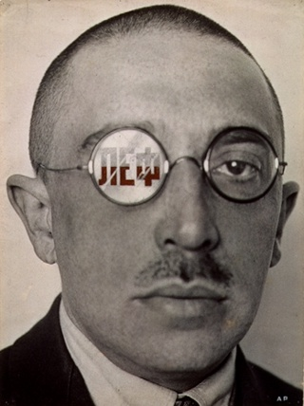

**Fig. 1** Rodchenko, A. (1924) *Osip Brik*, The Pushkin State Museum of Fine Arts, Moscow. <<http://bit.ly/ONlrfB>>.